**WebTech Lab DA-1**

**Binayak Bishnu**

**20BIT0155**

Qs1

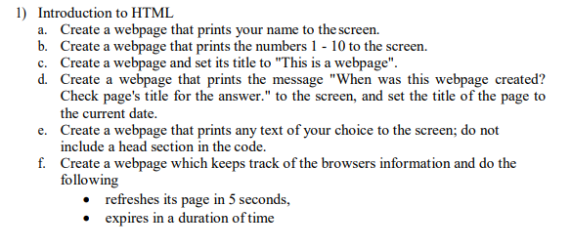

<!DOCTYPE html>

<html lang="en">

<head>

    <meta charset="UTF-8">

    <meta http-equiv="X-UA-Compatible" content="IE=edge">

    <meta name="viewport" content="width=device-width, initial-scale=1.0">

    <title>Exercise 1a</title>

</head>

<body>

    <h1 align="center">Binayak</h1>

    <h2 align="center">Binayak</h2>

    <h3 align="center">Binayak</h3>

    <h4 align="center">Binayak</h5>

    <h5 align="center">Binayak</h5>

    <h6 align="center">Binayak</h6>

</body>

</html>

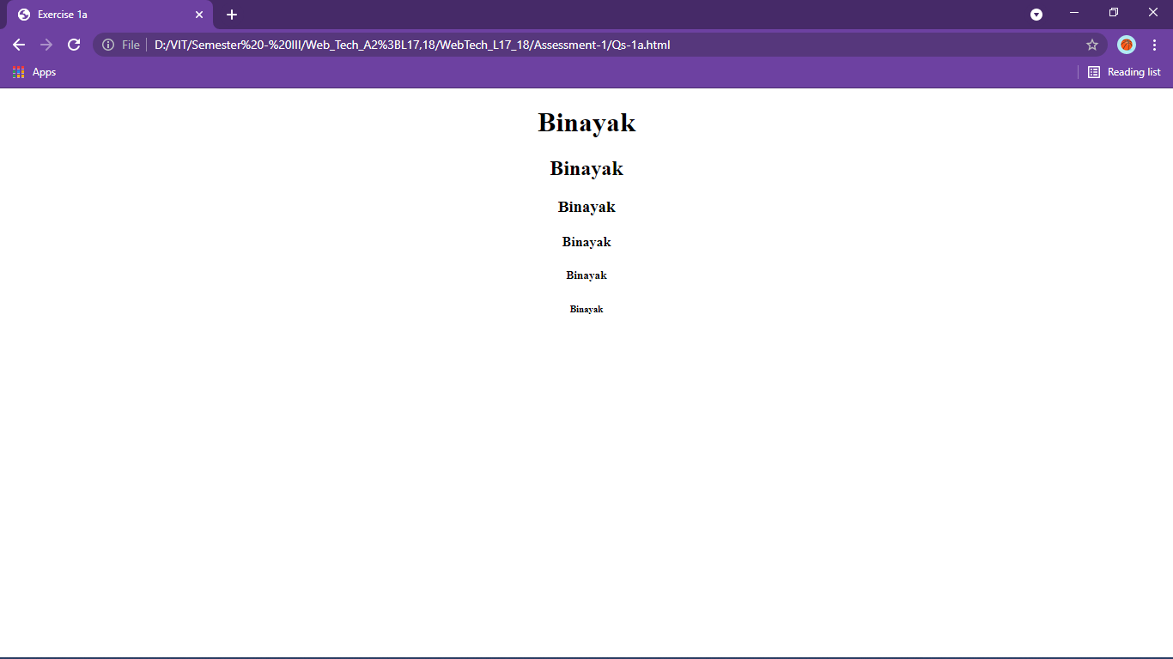

<!DOCTYPE html>

<html lang="en">

<head>

    <meta charset="UTF-8">

    <meta http-equiv="X-UA-Compatible" content="IE=edge">

    <meta name="viewport" content="width=device-width, initial-scale=1.0">

    <title>Exercise 1b</title>

</head>

<body bgcolor="yellow">

    <h3 align="center">1</h3>

    <h3 align="center">2</h3>

    <h3 align="center">3</h3>

    <h3 align="center">4</h3>

    <h3 align="center">5</h3>

    <h3 align="center">6</h3>

    <h3 align="center">7</h3>

    <h3 align="center">8</h3>

    <h3 align="center">9</h3>

    <h3 align="center">10</h3>

</body>

</html>

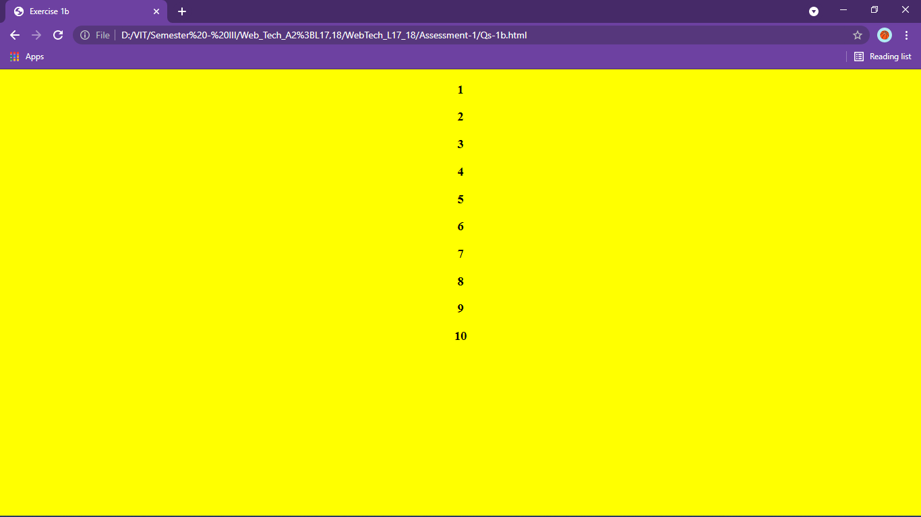

<!DOCTYPE html>

<html lang="en">

<head>

    <meta charset="UTF-8">

    <meta http-equiv="X-UA-Compatible" content="IE=edge">

    <meta name="viewport" content="width=device-width, initial-scale=1.0">

    <title>This is a webpage</title>

</head>

<body bgcolor="yellow" text="red">

    <h2>Exercise 1c</h2>

    <p>changing title</p>

</body>

</html>

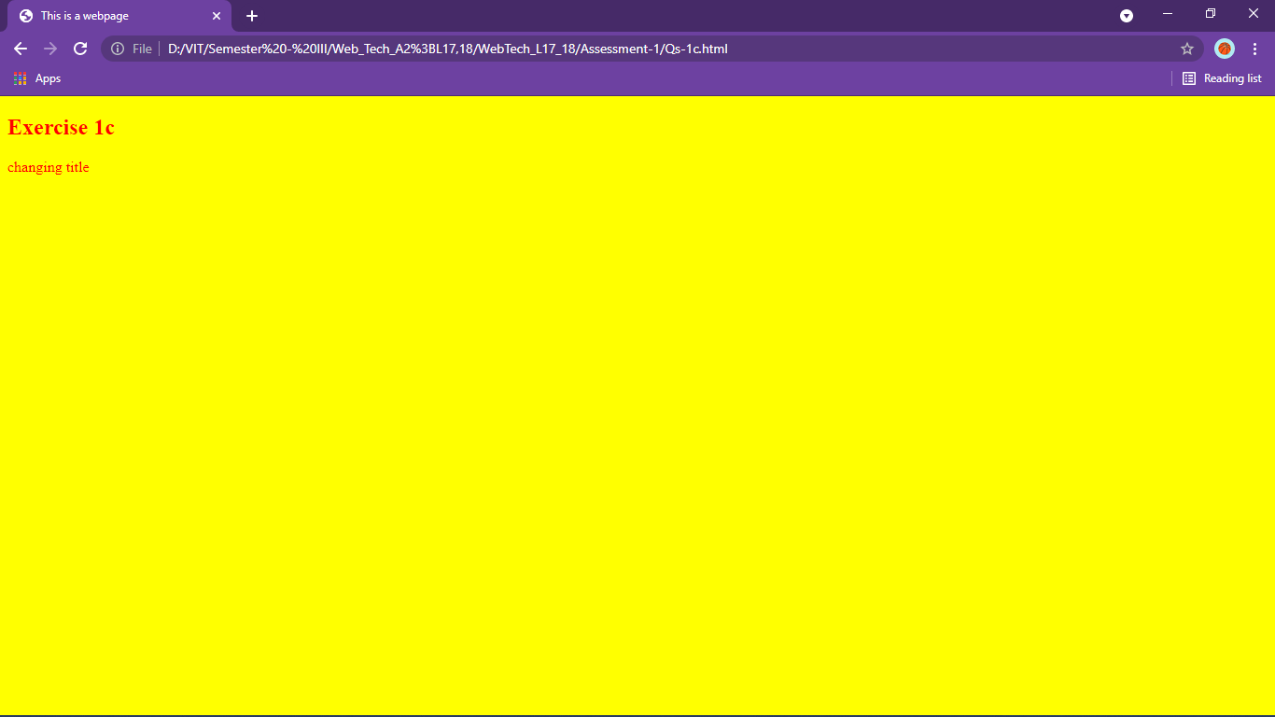

<!DOCTYPE html>

<html lang="en">

<head>

    <meta charset="UTF-8">

    <meta http-equiv="X-UA-Compatible" content="IE=edge">

    <meta name="viewport" content="width=device-width, initial-scale=1.0">

    <title>4th August 2021</title>

</head>

<body>

    <h2>When was this webpage created?</h2>

    <p><b>Check the page's title for the answer</b></p>

</body>

</html>

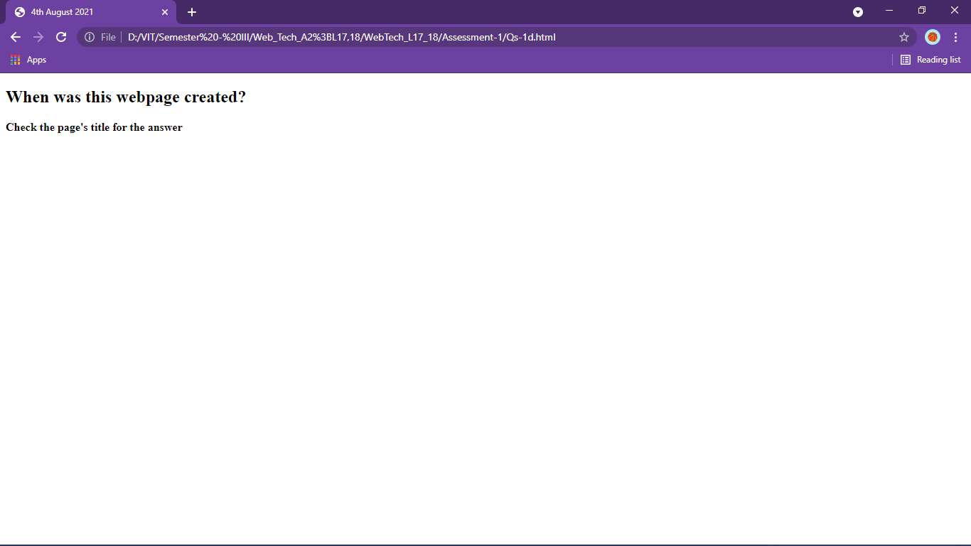

<!DOCTYPE html>

<html lang="en">

<!-- <head>

    <meta charset="UTF-8">

    <meta http-equiv="X-UA-Compatible" content="IE=edge">

    <meta name="viewport" content="width=device-width, initial-scale=1.0">

    <title>Exercise 1e</title>

</head> -->

<body>

    <h1>No title tag</h1>

    <p>Lorem ipsum dolor sit amet consectetur.</p>

    <p>Eligendi, aliquid consequuntur. Quas, unde sint.</p>

    <p>Recusandae a repellat alias veritatis voluptatibus?</p>

    <p>Fugiat nobis temporibus itaque nihil nostrum.</p>

</body>

</html>

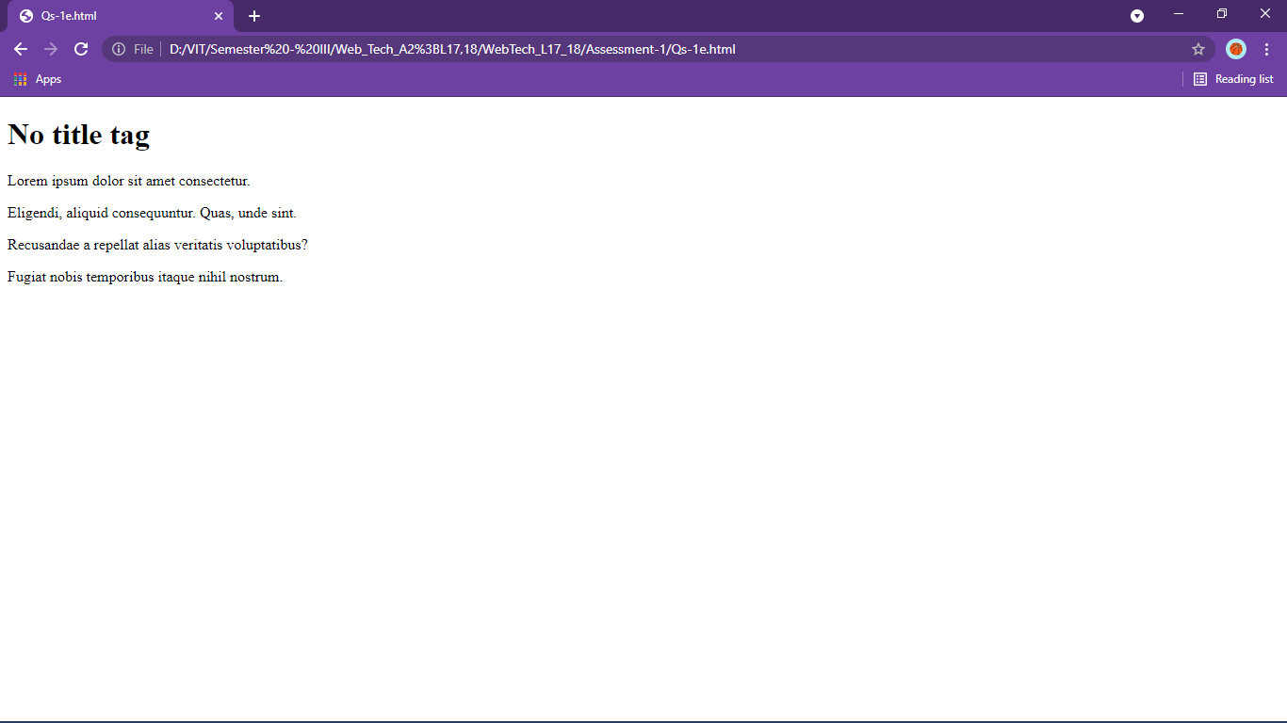

<!DOCTYPE html>

<html lang="en">

<body>

    <h1>No title tag</h1>

    <p>Lorem ipsum dolor sit amet consectetur.</p>

    <p>Eligendi, aliquid consequuntur. Quas, unde sint.</p>

    <p>Recusandae a repellat alias veritatis voluptatibus?</p>

    <p>Fugiat nobis temporibus itaque nihil nostrum.</p>

</body>

</html>

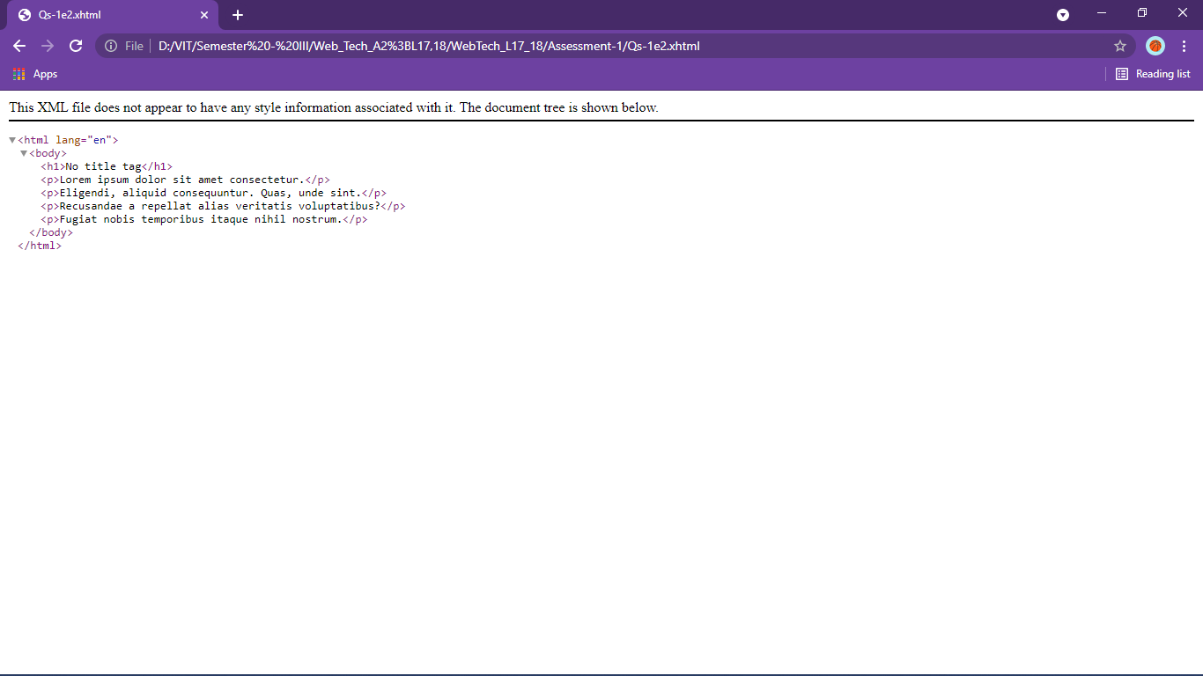

Qs2

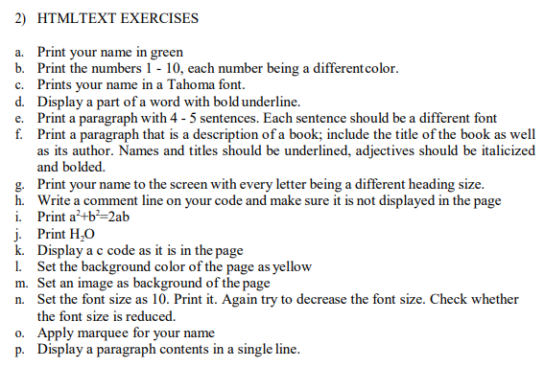

<!DOCTYPE html>

<html lang="en">

<head>

    <meta charset="UTF-8">

    <meta http-equiv="X-UA-Compatible" content="IE=edge">

    <meta name="viewport" content="width=device-width, initial-scale=1.0">

    <title>Exercise 2a</title>

</head>

<body>

    <!-- 2.a. -->

    <p style="color: #00ff00;">Binayak Bishnu</p>

</body>

</html>

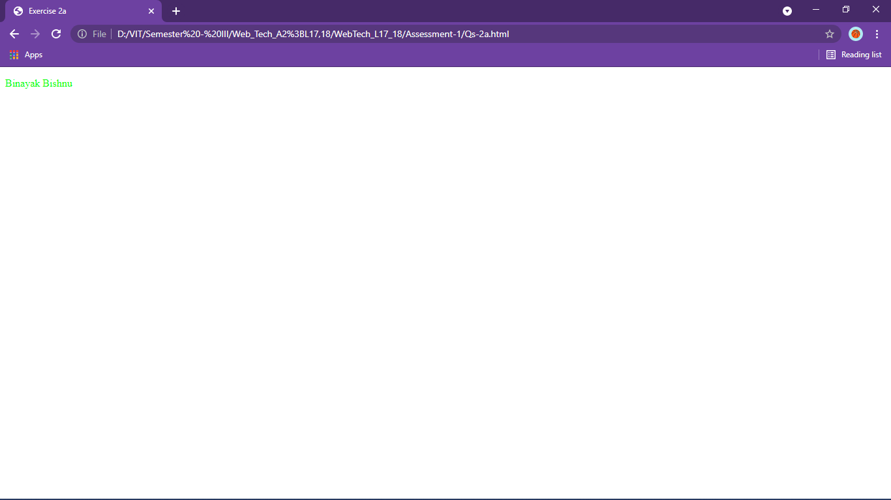

<!DOCTYPE html>

<html lang="en">

<head>

    <meta charset="UTF-8">

    <meta http-equiv="X-UA-Compatible" content="IE=edge">

    <meta name="viewport" content="width=device-width, initial-scale=1.0">

    <title>Exercise 2b</title>

</head>

<body>

    <p style="color: green;">1</p>

    <p style="color: red;">2</p>

    <p style="color: purple;">3</p>

    <p style="color: violet;">4</p>

    <p style="color: blue;">5</p>

    <p style="color: lightblue;">6</p>

    <p style="color: teal;">7</p>

    <p style="color: turquoise;">8</p>

    <p style="color: blueviolet;">9</p>

    <p style="color: yellowgreen;">10</p>

</body>

</html>

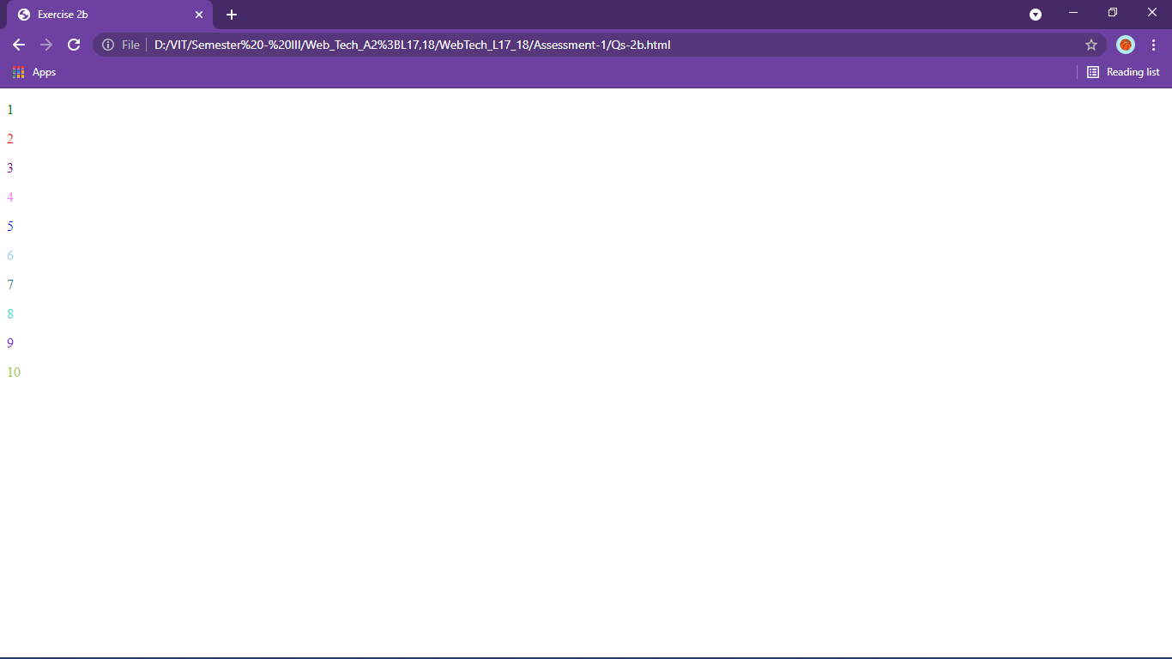

<!DOCTYPE html>

<html lang="en">

<head>

    <meta charset="UTF-8">

    <meta http-equiv="X-UA-Compatible" content="IE=edge">

    <meta name="viewport" content="width=device-width, initial-scale=1.0">

    <title>Exercise 2c</title>

</head>

<body>

    <p style="font-family:Verdana, Geneva, Tahoma, sans-serif">Binayak Bishnu</p>

</body>

</html>

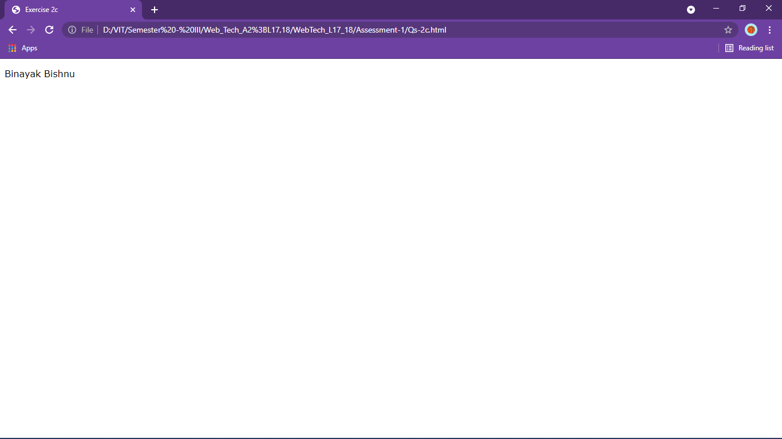

<!DOCTYPE html>

<html lang="en">

<head>

    <meta charset="UTF-8">

    <meta http-equiv="X-UA-Compatible" content="IE=edge">

    <meta name="viewport" content="width=device-width, initial-scale=1.0">

    <title>Exercise 2d</title>

</head>

<body>

    <p>My name is <u><b>Binayak</b></u></p>

</body>

</html>

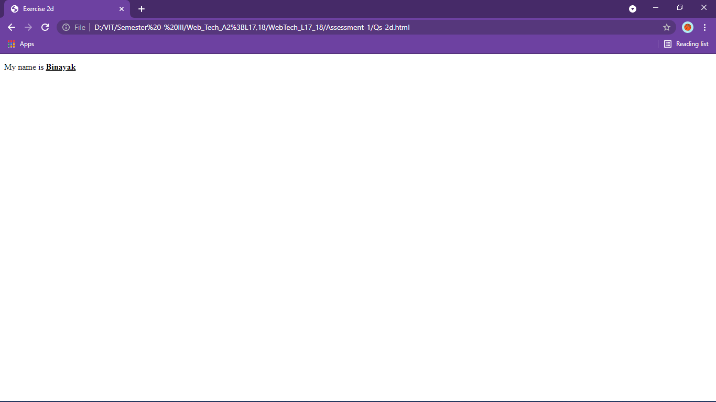

<!DOCTYPE html>

<html lang="en">

<head>

    <meta charset="UTF-8">

    <meta http-equiv="X-UA-Compatible" content="IE=edge">

    <meta name="viewport" content="width=device-width, initial-scale=1.0">

    <title>Exercise 2e</title>

</head>

<body>

    <p>

        <span style="font-family: Arial, Helvetica, sans-serif;">Lorem ipsum dolor sit amet, consectetur adipisicing elit.</span>

        <span style="font-family: Cambria, Cochin, Georgia, Times, 'Times New Roman', serif;">Tempora iste ea quaerat beatae accusamus laborum modi.</span>

        <span style="font-family: Georgia, 'Times New Roman', Times, serif;">Optio facilis ullam, quis sequi expedita pariatur eveniet!</span>

        <span style="font-family: 'Franklin Gothic Medium', 'Arial Narrow', Arial, sans-serif;">Consectetur similique quos, qui illo amet provident alias.</span>

        <span style="font-family: Impact, Haettenschweiler, 'Arial Narrow Bold', sans-serif;">Error, repudiandae. Numquam quaerat repudiandae beatae eaque nobis.</span>

    </p>

</body>

</html>

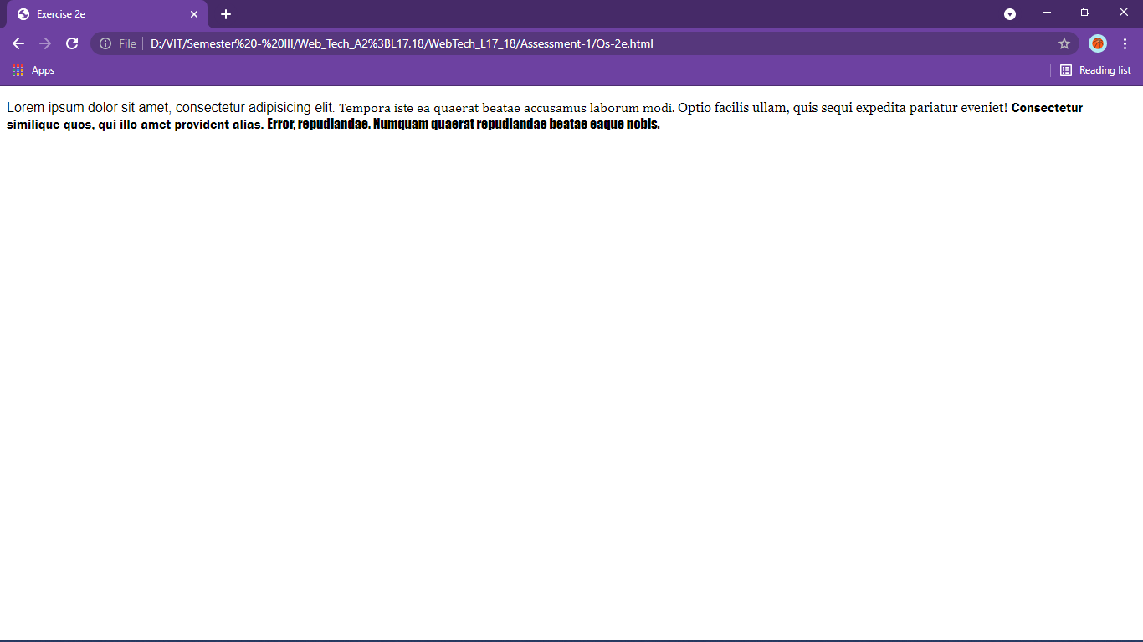

<!DOCTYPE html>

<html lang="en">

<head>

    <meta charset="UTF-8">

    <meta http-equiv="X-UA-Compatible" content="IE=edge">

    <meta name="viewport" content="width=device-width, initial-scale=1.0">

    <title>Exercise 2f</title>

</head>

<body>

    <p><span style="font-size: 1.2em;"><u>The Alchemist</u></span> by <u>Paulo Coelho.</u> It follows the journey of an <span style="font-style: italic; font-weight:bold">Andalusian</span> shepherd boy. Believing a recurring dream to be <span style="font-style: italic; font-weight:bold">prophetic</span>, he asks a Gypsy fortune teller in the nearby town about its meaning. The woman interprets the dream as a prophecy telling the boy that he will discover a treasure at the Egyptian pyramids.</p>

</body>

</html>

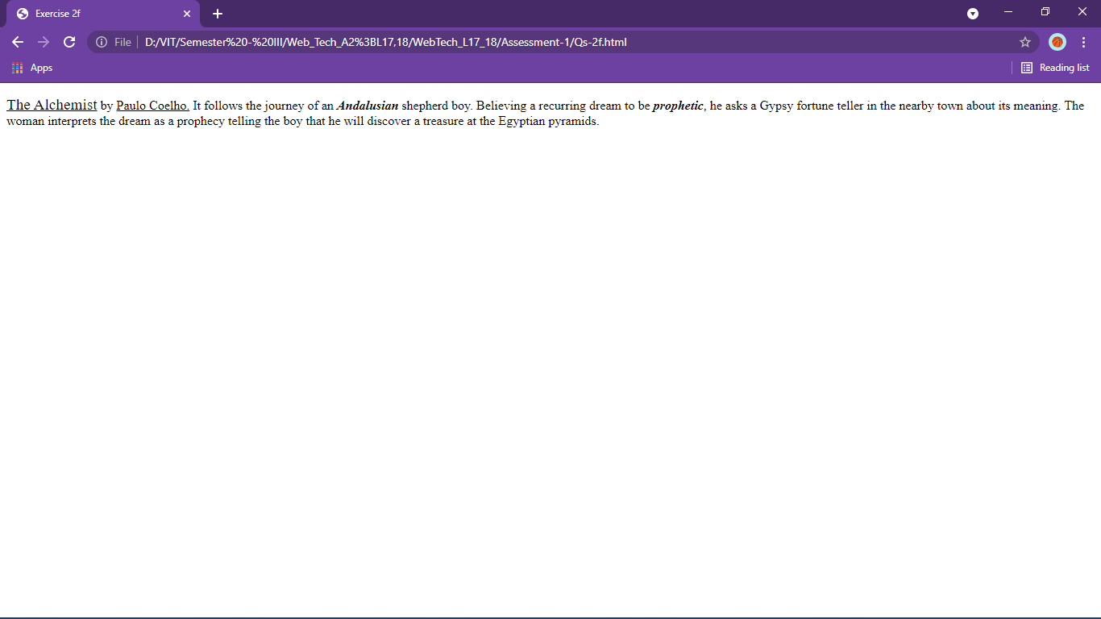

<!DOCTYPE html>

<html lang="en">

<head>

    <meta charset="UTF-8">

    <meta http-equiv="X-UA-Compatible" content="IE=edge">

    <meta name="viewport" content="width=device-width, initial-scale=1.0">

    <title>Exercise 2g</title>

</head>

<body>

    <h1>B</h1><h2>i</h2><h3>n</h3><h4>a</h4><h5>y</h5><h6>a</h6><h7>k</h7>

</body>

</html>

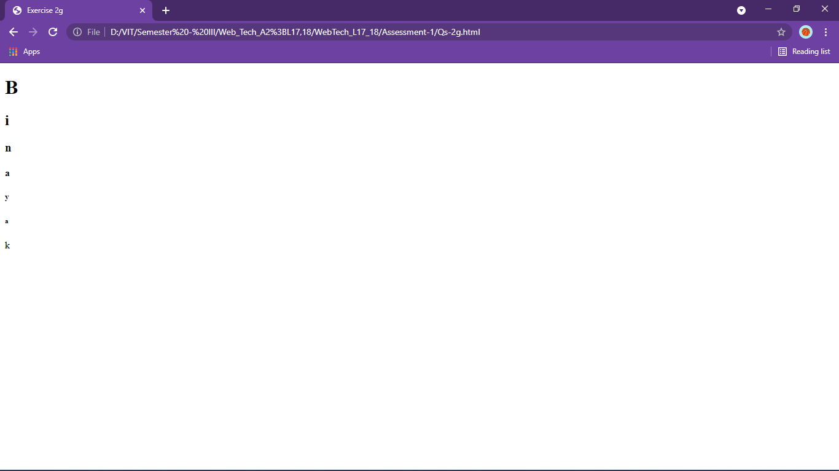

<html>

    <head>

        <title>Exercise 2h</title>

    </head>

    <body>

        <!-- this is a comment -->

        This is not a comment

    </body>

</html>

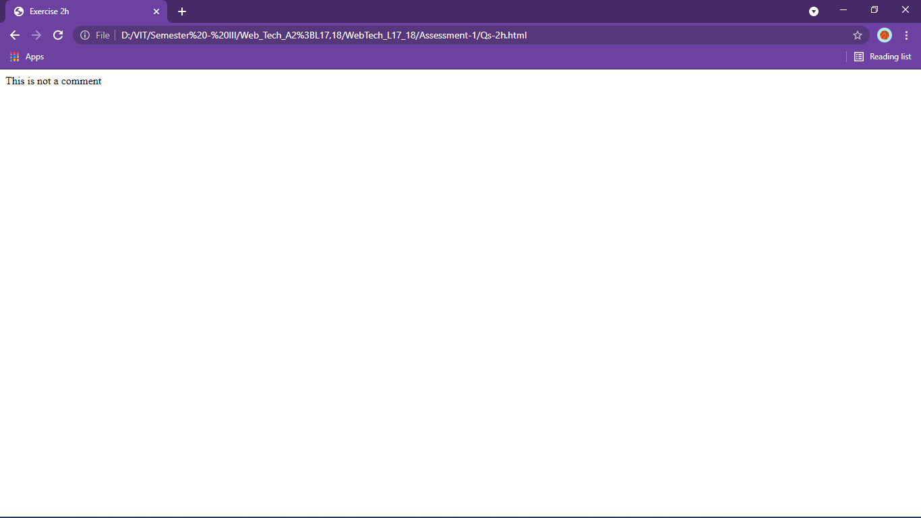

<html>

    <head>

        <title>Exercise 2i</title>

    </head>

    <body>

        <var>a</var><sup>2</sup>+<var>b</var><sup>2</sup>=2<var>a</var><var>b</var>

    </body>

</html>

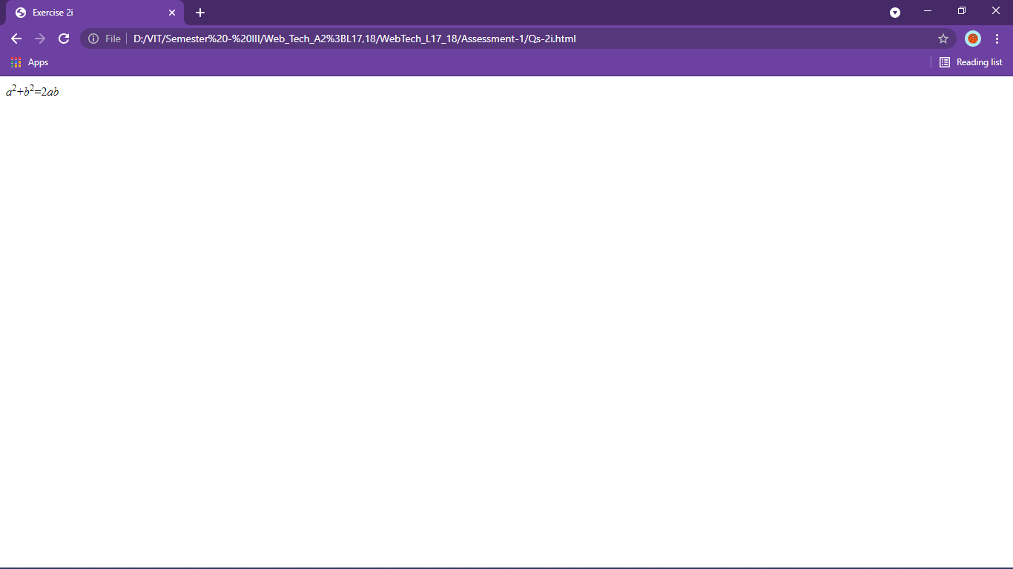

<html>

    <head>

        <title>Exercise 2j</title>

    </head>

    <body>

        <var>H</var><sub>2</sub><var>O</var>

    </body>

</html>

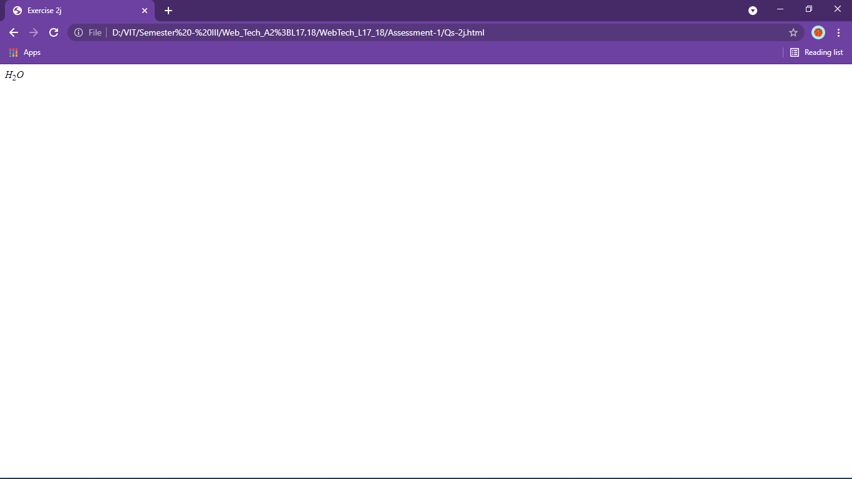

<html>

    <head>

        <title>Exercise 2k</title>

    </head>

    <body>

<pre>

<!-- pre formatted tag to make it exact as written -->

#include &lt;stdio.h&gt;

<!-- <stdio.h> identified as tag -->

int main() {

    int num;

    printf("Enter an integer: ");

    scanf("%d", &num);

    // true if num is perfectly divisible by 2

    if(num % 2 == 0)

        printf("%d is even.", num);

    else

        printf("%d is odd.", num);

    return 0;

}

</pre>

    </body>

</html>

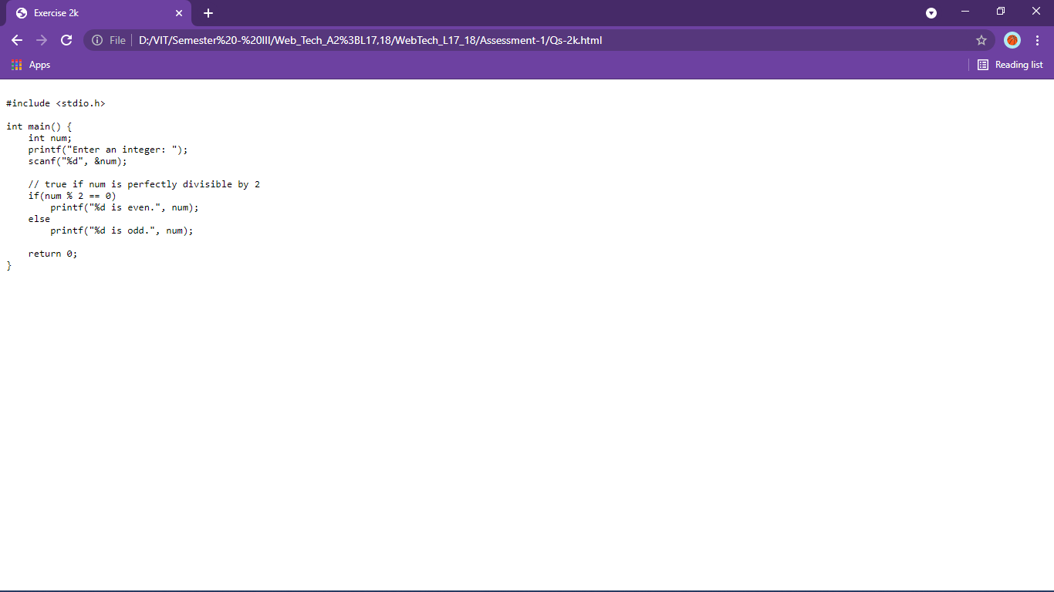

<html>

    <head>

        <title>Exercise 2l</title>

    </head>

    <body bgcolor="Yellow">

        <p>Text</p>

    </body>

</html>

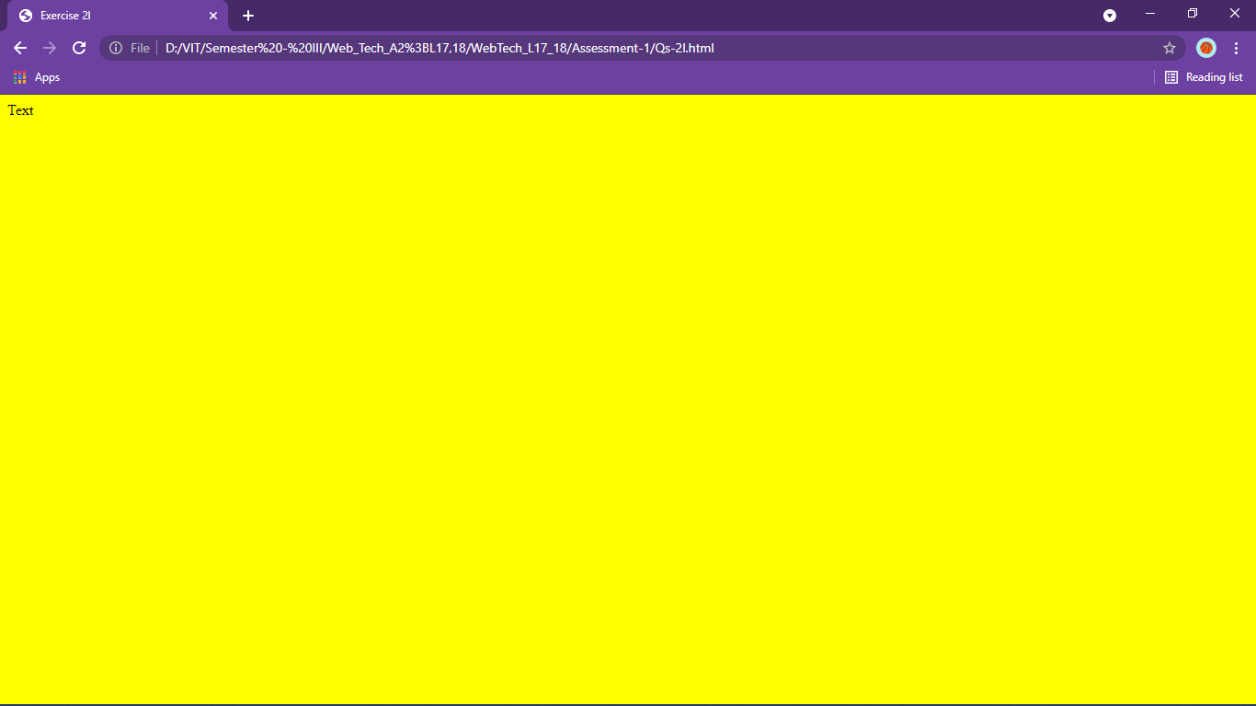

<html>

    <head>

        <title>Exercise 2m</title>

    </head>

    <body background="pic.png">

        <h1 style="color:white">Text</h1>

    </body>

</html>

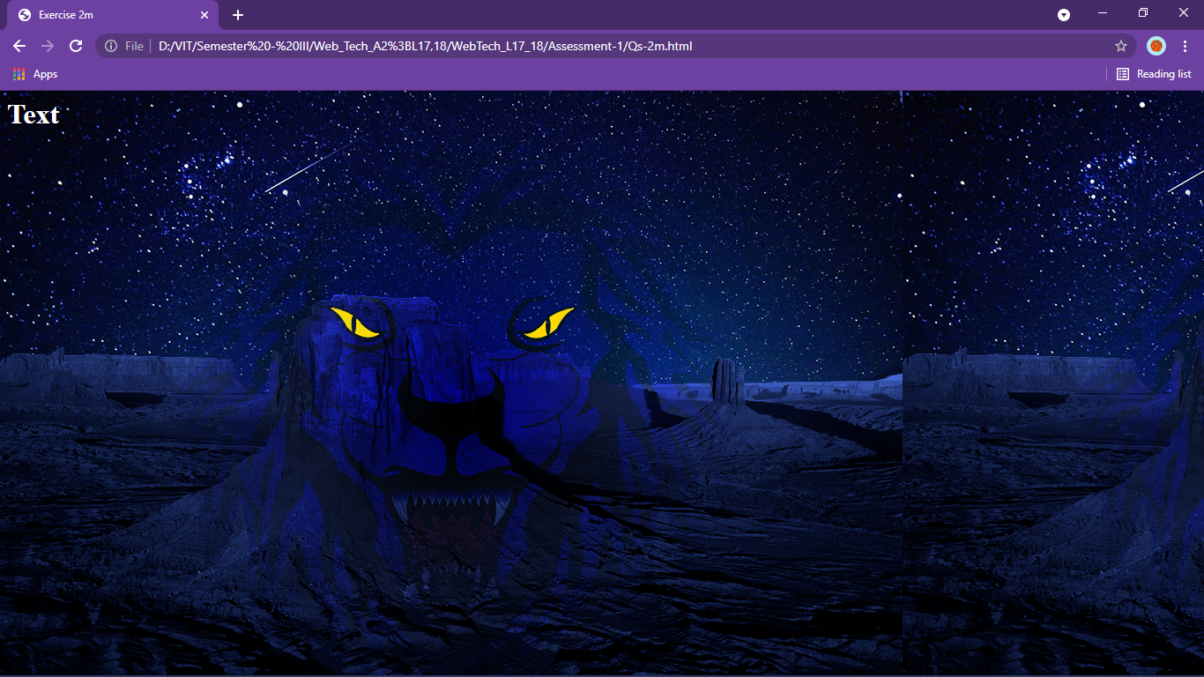

<html>

    <head>

        <title>Exercise 2n</title>

    </head>

    <body>

        <font size="5">Text</font>

        <!-- yes, reducing -->

    </body>

</html>

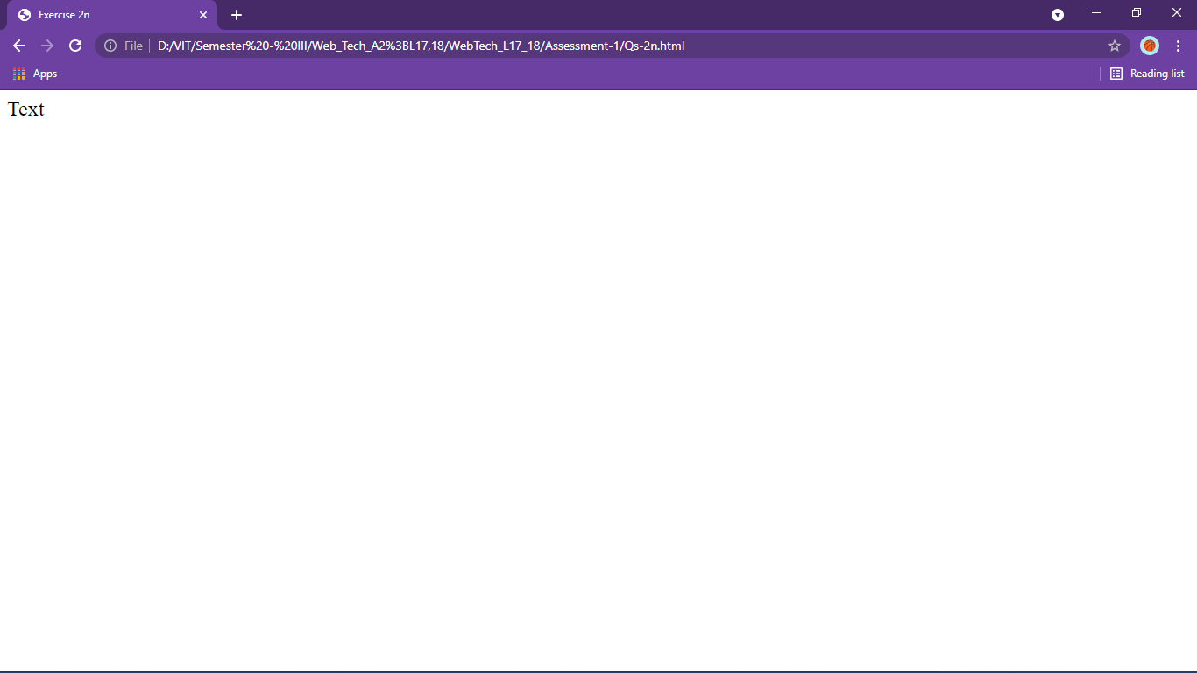

<html>

    <head>

        <title>Exercise 2o</title>

    </head>

    <body>

        <!--behavior="slide"-->

        <marquee direction="left"

        behavior="alternate"

        width="300px">

            Binayak Bishnu

        </marquee>

    </body>

</html>

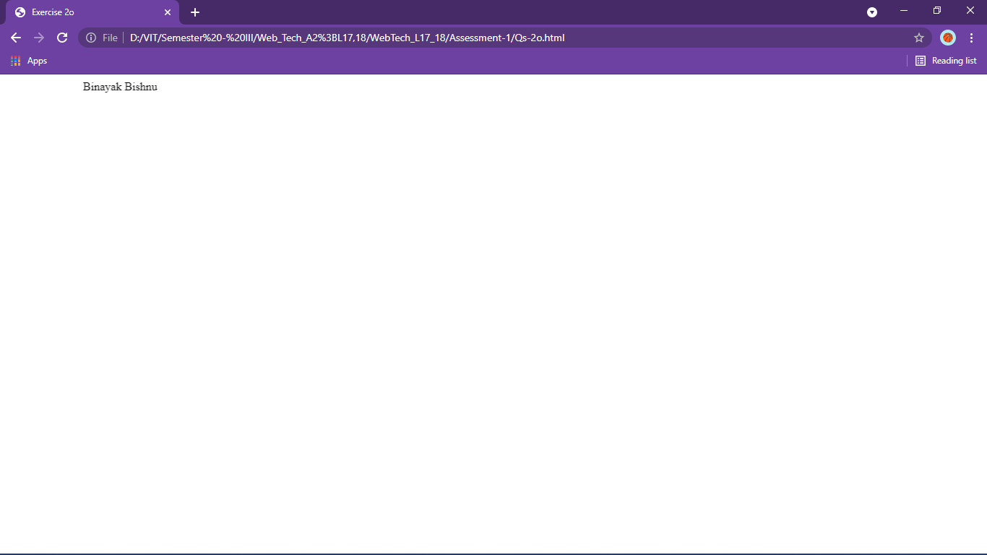

<html>

    <head>

        <title>Exercise 2p</title>

    </head>

    <body>

        <p style="font-size:14">Lorem ipsum dolor sit amet, consectetur adipiscing elit, sed do eiusmod tempor incididunt ut labore et dolore magna aliqua.</p>

    </body>

</html>

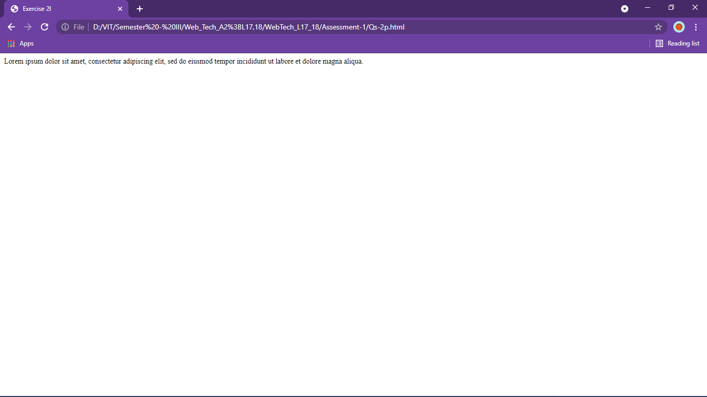

Qs3

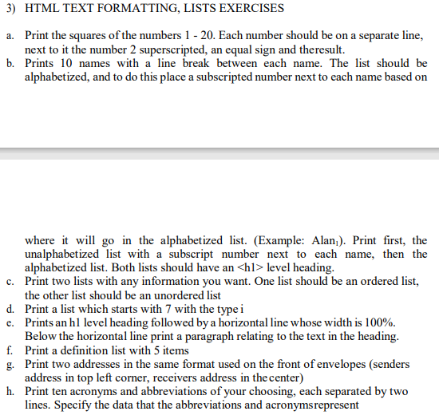

<html>

<head>

    <title>Exercise 3a</title>

</head>

<body>

    <p>1<sup>2</sup>=1

    <p>2<sup>2</sup>=4

    <p>3<sup>2</sup>=9

    <p>4<sup>2</sup>=16

    <p>5<sup>2</sup>=25

    <p>6<sup>2</sup>=36

    <p>7<sup>2</sup>=49

    <p>8<sup>2</sup>=64

    <p>9<sup>2</sup>=81

    <p>10<sup>2</sup>=100

    <p>11<sup>2</sup>=121

    <p>12<sup>2</sup>=144

    <p>13<sup>2</sup>=169

    <p>14<sup>2</sup>=196

    <p>15<sup>2</sup>=225

    <p>16<sup>2</sup>=256

    <p>17<sup>2</sup>=284

    <p>18<sup>2</sup>=324

    <p>19<sup>2</sup>=361

    <p>20<sup>2</sup>=400

</body>

</html>

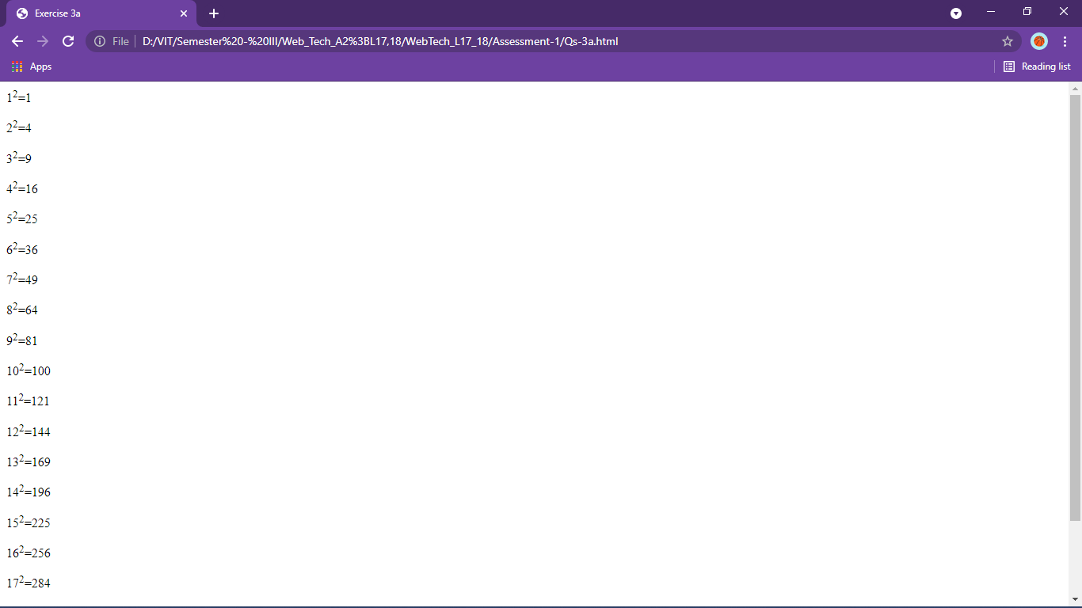

<!DOCTYPE html>

<html lang="en">

<head>

    <title>Exercise 3b</title>

</head>

<body>

    <h1>Unalphabetized</h1>

    <p>Binayak<sub>3</sub></p>

    <p>Ayush<sub>2</sub></p>

    <p>Gautam<sub>5</sub></p>

    <p>Harish<sub>6</sub></p>

    <p>Ram<sub>8</sub></p>

    <p>Shyam<sub>10</sub></p>

    <p>Rohan<sub>9</sub></p>

    <p>Arya<sub>1</sub></p>

    <p>Deepak<sub>4</sub></p>

    <p>Raj<sub>7</sub></p>

    <h1>Alphabetized</h1>

    <p>Arya</p>

    <p>Ayush</p>

    <p>Binayak</p>

    <p>Deepak</p>

    <p>Gautam</p>

    <p>Harish</p>

    <p>Raj</p>

    <p>Ram</p>

    <p>Rohan</p>

    <p>Shyam</p>

</body>

</html>

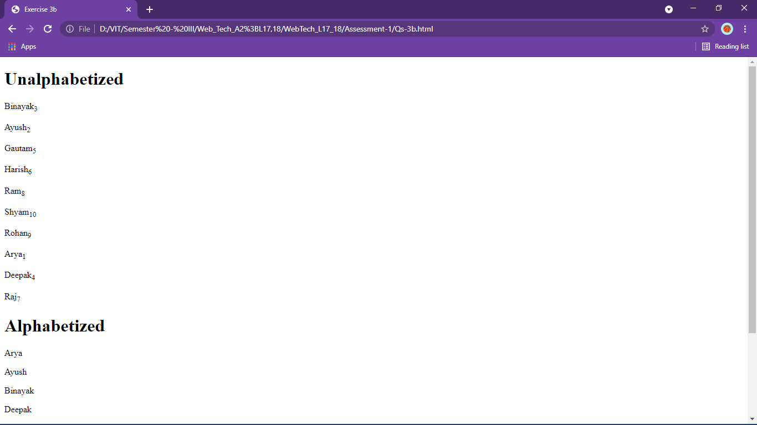

<!DOCTYPE html>

<html>

<head>

    <title>Exercise 3c</title>

</head>

<body>

    <h2>Ordered</h2>

    <ol type="i">

        <li>Binayak</li>

        <li>Bishnu</li>

        <ul type="disc">

            <li>Neon</li>

    </ol>

    <h2>Unordered</h2>

    <ul type="square">

        <li>First name</li>

        <li>Last name</li>

        <li>Game name</li>

    </ul>

</body>

</html>

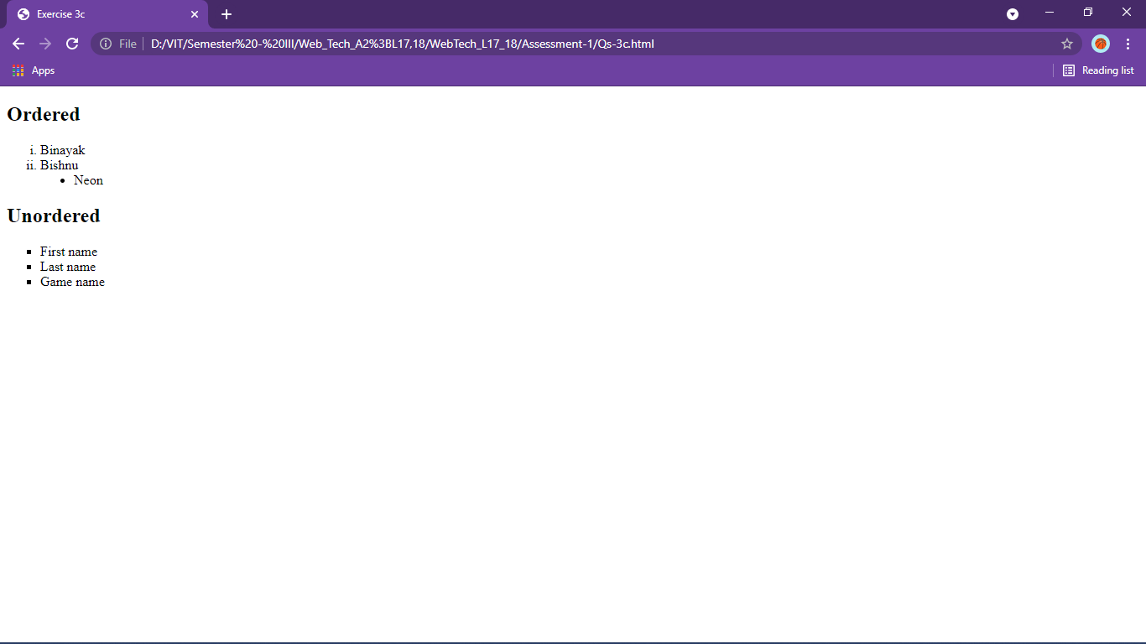

<!DOCTYPE html>

<html>

<head>

    <title>Exercise 3d</title>

</head>

<body>

    <ol type="i" start="7">

        <li>Binayak</li>

        <li>Bishnu</li>

        <li>Raj</li>

        <li>Shyam</li>

    </ol>

</body>

</html>

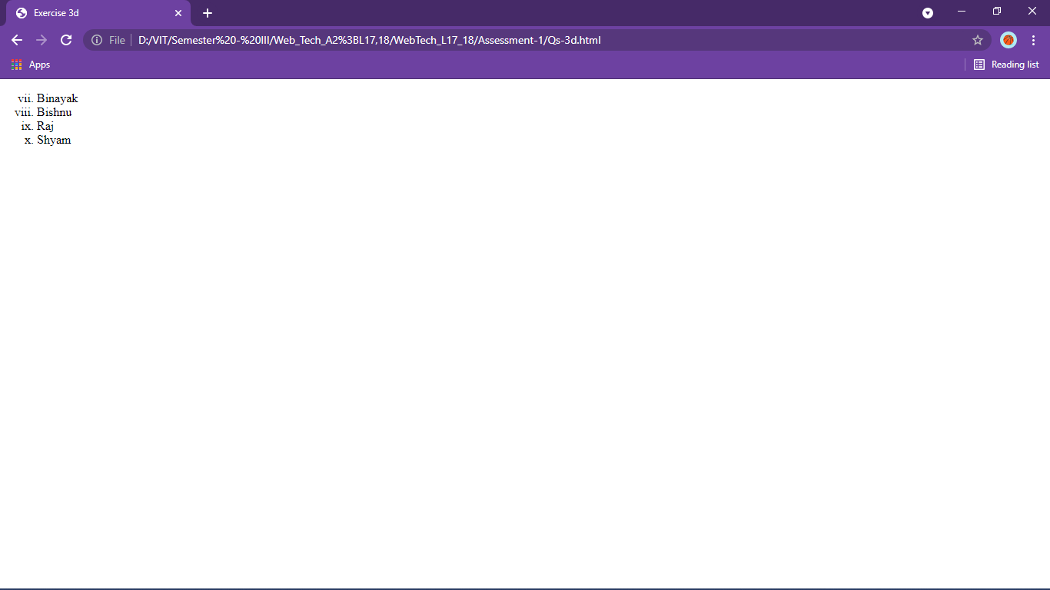

<!DOCTYPE html>

<html>

<head>

    <title>Exercise 3e</title>

</head>

<body>

    <h1>Sample Text (Lorem)</h1>

    <hr width="100%">

    <p align="justify">Lorem, ipsum dolor sit amet consectetur adipisicing elit. Quae officiis delectus, consequuntur

        inventore debitis aliquid deleniti voluptatibus reiciendis tenetur suscipit quod molestias recusandae. Non at

        sint doloribus repellat voluptas minima recusandae odit accusamus eos. Reprehenderit ipsam quo consequatur

        nesciunt asperiores ratione non, sint sed optio aperiam! Facere, veritatis unde, maiores, doloribus culpa

        voluptatem voluptates exercitationem consequuntur qui vel cumque explicabo pariatur perspiciatis architecto

        placeat dolores nostrum! Et consequuntur magnam, ab nostrum tempora repellat eaque corrupti exercitationem

        repudiandae! Deleniti mollitia praesentium reprehenderit ipsam quae. Provident corrupti laborum eveniet

        consectetur illum asperiores, excepturi sequi voluptatum magni sunt iste eum, cumque suscipit deserunt?</p>

</body>

</html>

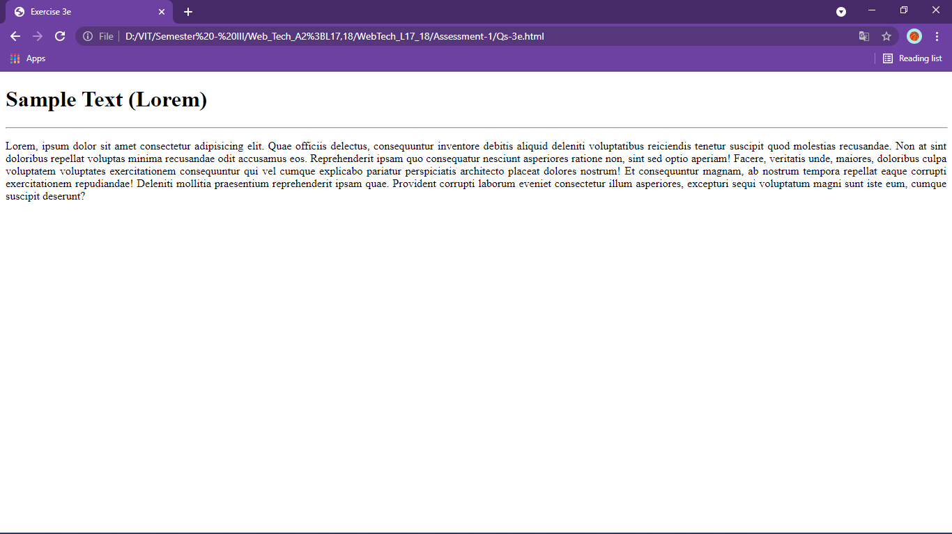

<!DOCTYPE html>

<html>

<head>

    <title>Exercise 3f</title>

</head>

<body>

    <dl>

        <dt>HTML</dt>

        <dd>Markup language</dd>

        <br />

        <dt>CSS</dt>

        <dd>add styles to html</dd>

        <br />

        <dt>JavaScript</dt>

        <dd>Scripting language</dd>

        <br />

        <dt>Bootstrap</dt>

        <dd>CSS framework</dd>

        <br />

        <dt>ReactJs</dt>

        <dd>JS library</dd>

    </dl>

</body>

</html>

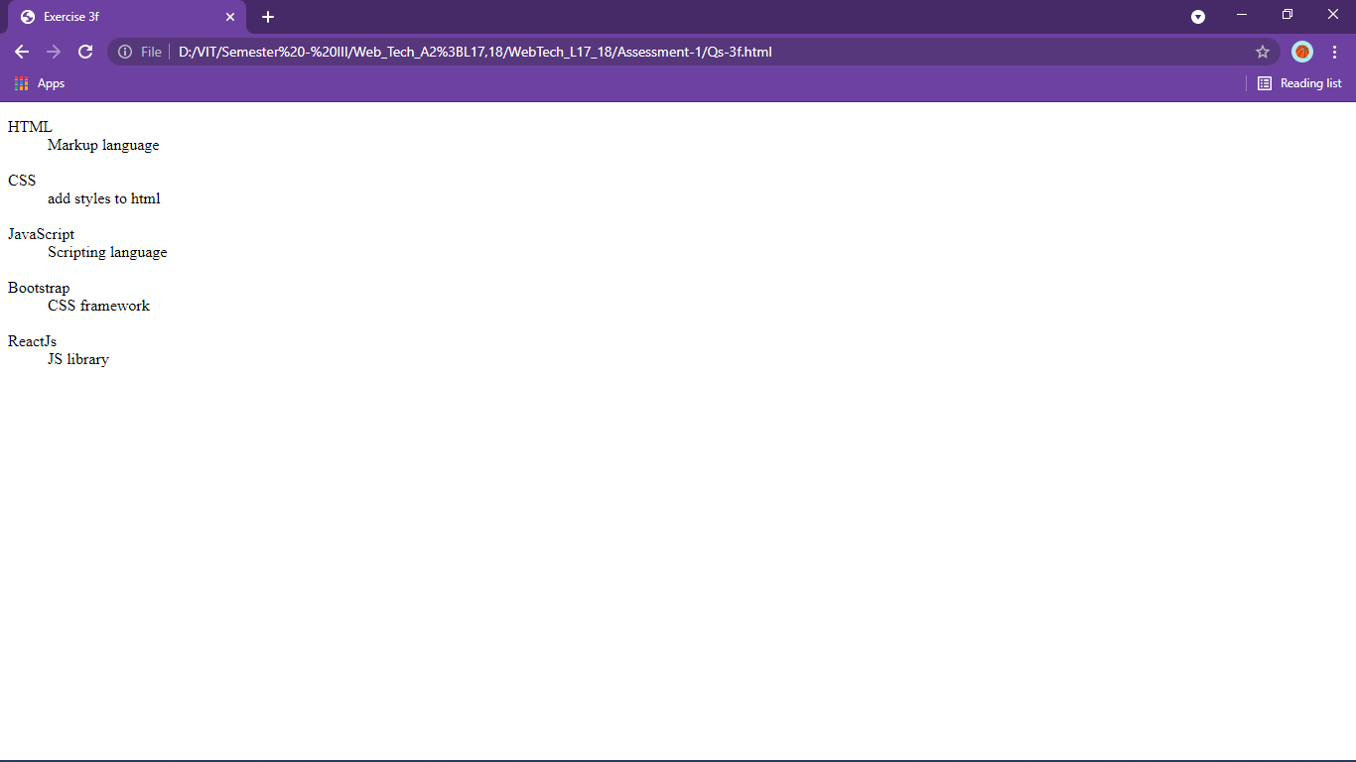

<!DOCTYPE html>

<html>

<head>

    <title>Exercise 3g</title>

</head>

<body>

    <address>

        <h3>Sender's address</h3>

        Lorem ipsum dolor sit amet consectetur.

    </address>

    <address align="center">

        <h3>Receiver's address</h3>

        Lorem ipsum dolor sit amet consectetur.

    </address>

</body>

</html>

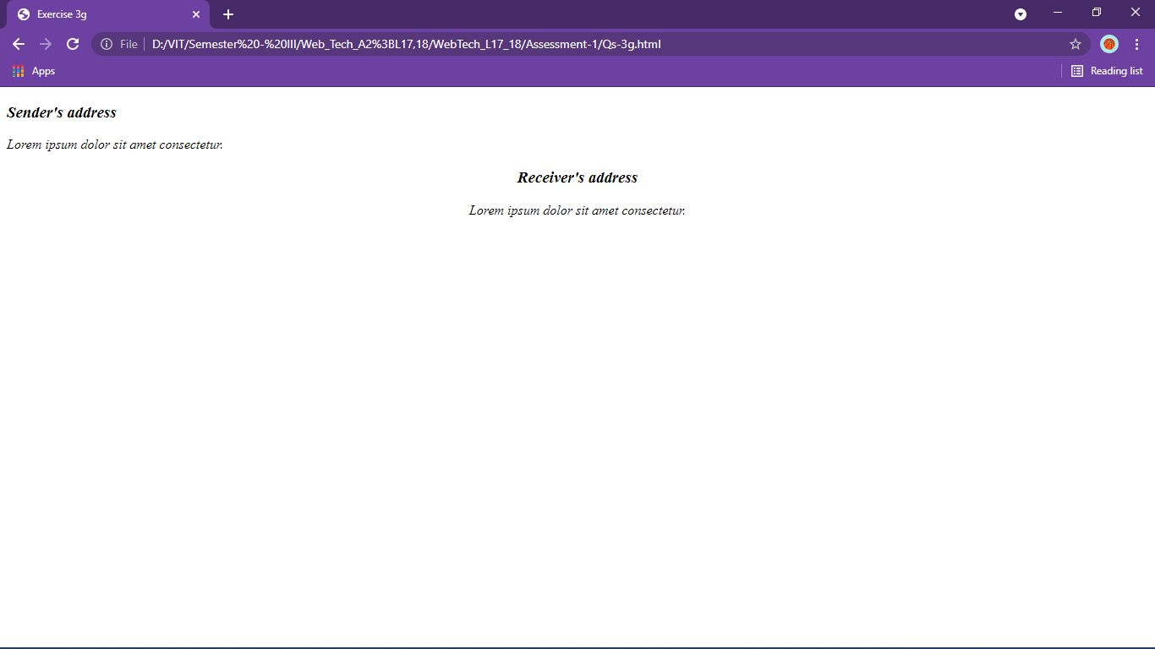

<!DOCTYPE html>

<html>

<head>

    <title>Exercise 3h</title>

</head>

<body>

    <acronym title="Java Development Toolkit">JDK</acronym><br /><br />

    <acronym title="School of Information Technology and Engineering">SITE</acronym><br /><br />

    <acronym title="SOund NAvigation and Ranging">SONAR</acronym><br /><br />

    <acronym title="Light Amplification by the Simulated Emission of Radiation">LASER</acronym><br /><br />

    <acronym title="TradeMark">TM</acronym><br /><br />

    <acronym title="Vellore Institute of Technology">VIT</acronym><br /><br />

    <acronym title="Indian Premier League">IPL</acronym><br /><br />

    <acronym title="Indian Super League">ISL</acronym><br /><br />

    <acronym title="Laughing Out Loud">LOL</acronym><br /><br />

    <abbr title="Message">Msg</abbr>

</body>

</html>

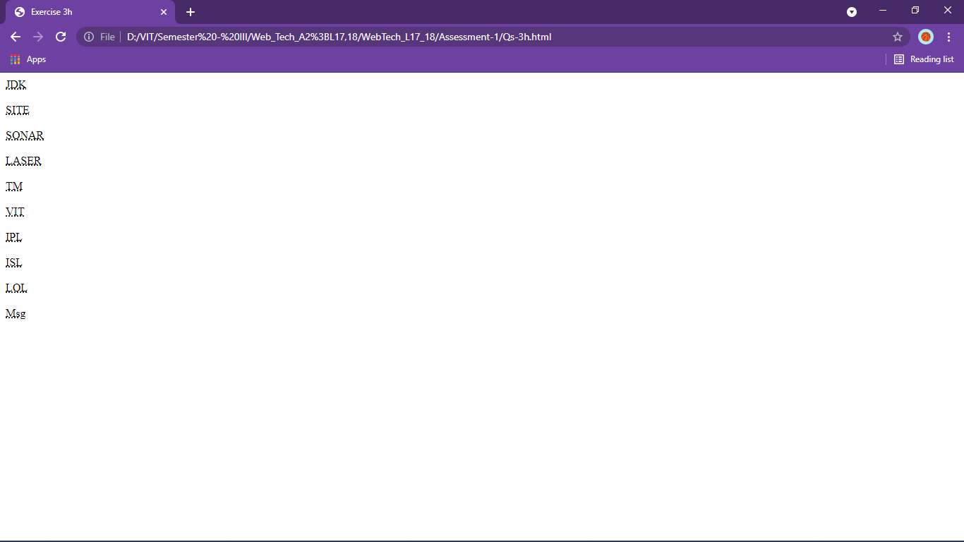

Qs4

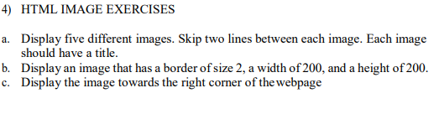

<!DOCTYPE html>

<html>

<head>

    <title>Exercise 4a</title>

</head>

<body>

    <h2>a</h2>

    <img title="a" alt="not found" src="pexels-hasan-albari-1229861.jpg" width="200px" /><br /><br />

    <h2>b</h2>alt="not found"

    <img title="b" alt="not found" src="pexels-felix-mittermeier-956999.jpg" width="200px" /><br /><br />

    <h2>c</h2>alt="not found"

    <img title="c" alt="not found" src="pexels-pixabay-531880.jpg" width="200px" /><br /><br />

    <h2>d</h2>alt="not found"

    <img title="d" alt="not found" src="pexels-quintin-gellar-313782.jpg" width="200px" /><br /><br />

    <h2>e</h2>alt="not found"

    <img title="e" alt="not found" src="pexels-s-migaj-747964.jpg" width="200px" />

</body>

</html>

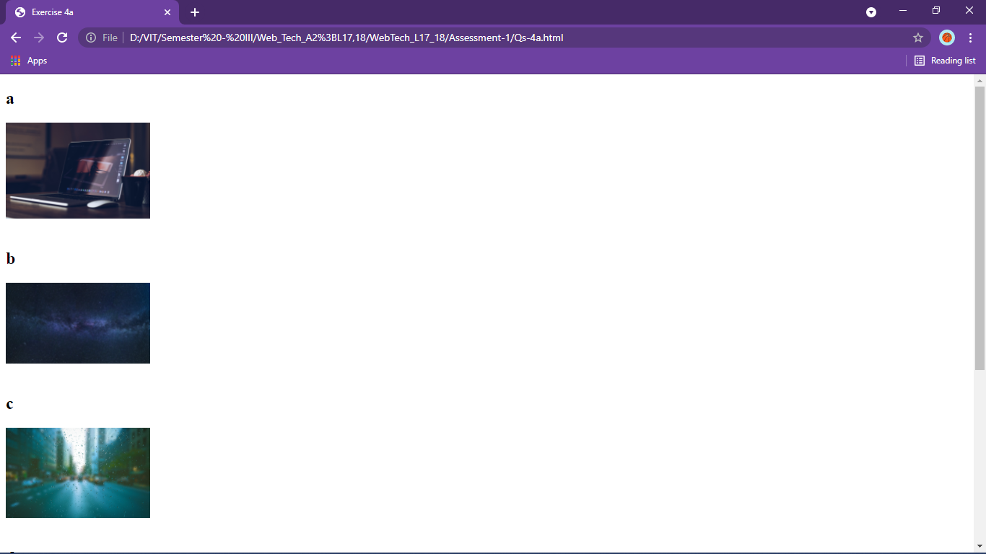

<!DOCTYPE html>

<html>

<head>

    <title>Exercise 4b</title>

</head>

<body>

    <img alt="not found" src="pexels-s-migaj-747964.jpg" border="2x" width="200px" height="200px">

</body>

</html>

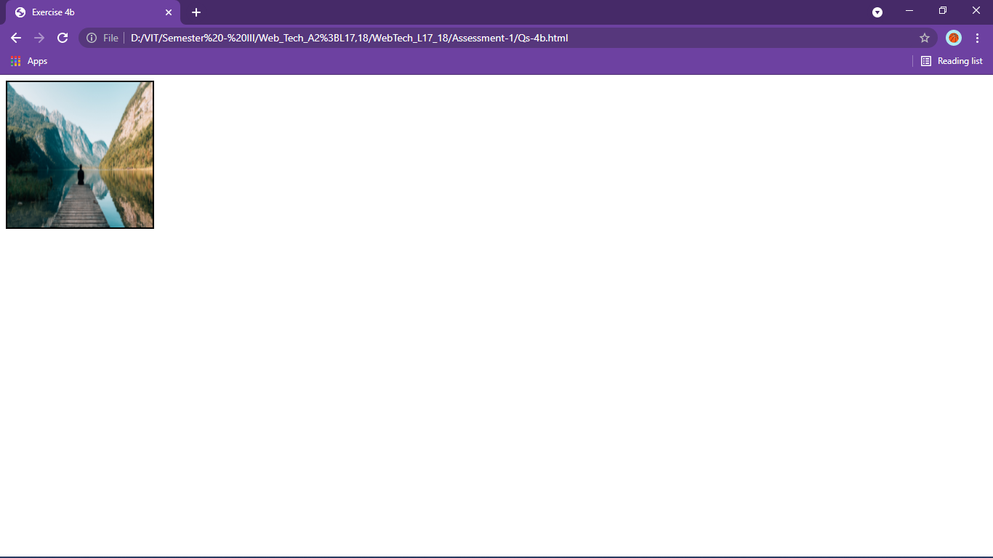

<!DOCTYPE html>

<html lang="en">

<head>

    <meta charset="UTF-8">

    <meta http-equiv="X-UA-Compatible" content="IE=edge">

    <meta name="viewport" content="width=device-width, initial-scale=1.0">

    <title>Exercise 4c</title>

</head>

<body>

    <img alt="not found" src="pexels-pixabay-531880.jpg" align="right" width="200px" />

</body>

</html>

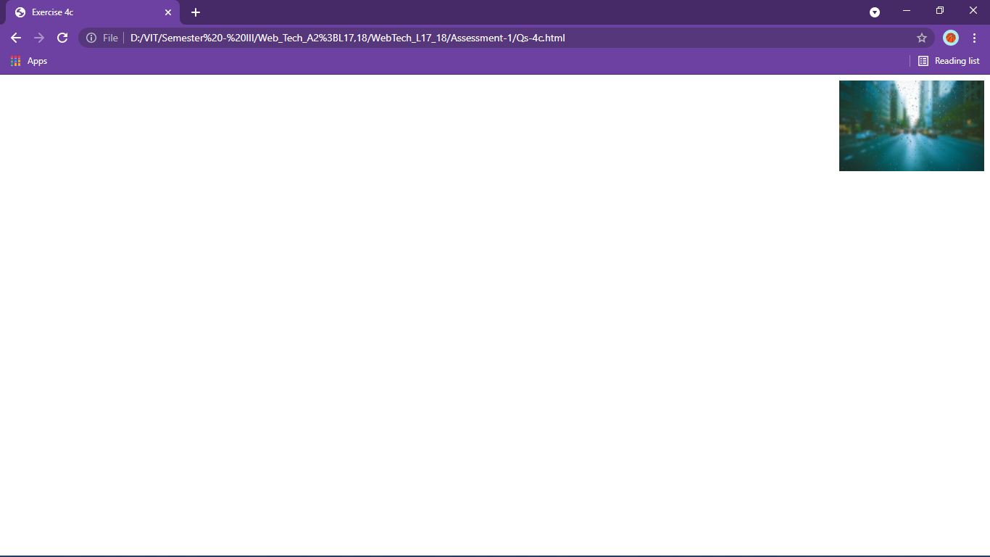

Qs 5

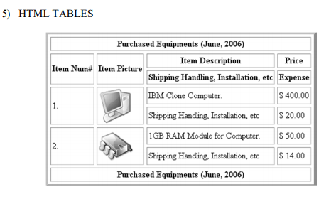

<!DOCTYPE html>

<html>

<head>

    <title>Exercise 5</title>

</head>

<body>

    <table border="4" cellspacing="2" cellpadding="6">

        <thead align="center">

            <tr>

                <th colspan="4">Purchased Equipments (June, 2006)</th>

            </tr>

            <tr>

                <th rowspan="2">Item Num#</th>

                <th rowspan="2">Item Picture</th>

                <th>Item Description</th>

                <th>Price</th>

            </tr>

            <tr>

                <th>Shipping Handling, Installation, etc</th>

                <th>Expense</th>

            </tr>

        </thead>

        <tfoot>

            <tr>

                <th colspan="4">Purchased Equipments (June, 2006)</th>

            </tr>

        </tfoot>

        <tbody>

            <tr>

                <td rowspan="2">1.</td>

                <td rowspan="2"><img width="100px" alt="NaN" src="6570251-computer-illustration.jpg" /></td>

                <td>IBM Clone Computer</td>

                <td>&dollar; 400.00</td>

            </tr>

            <tr>

                <td>Shipping Handling, Installation, etc</td>

                <td>&dollar; 20.00</td>

            </tr>

            <tr>

                <td rowspan="2">2.</td>

                <td rowspan="2">

                    <img width="100px" alt="NaN" src="500_F_87416667_iNfTIRo8TmZYQonSlyRYrDwRbOUkuTNS.jpg" />

                </td>

                <td>1 GB RAM Module for Computer</td>

                <td>&dollar; 50.00</td>

            </tr>

            <tr>

                <td>Shipping Handling, Installation, etc</td>

                <td>&dollar; 14.00</td>

            </tr>

        </tbody>

    </table>

</body>

</html>

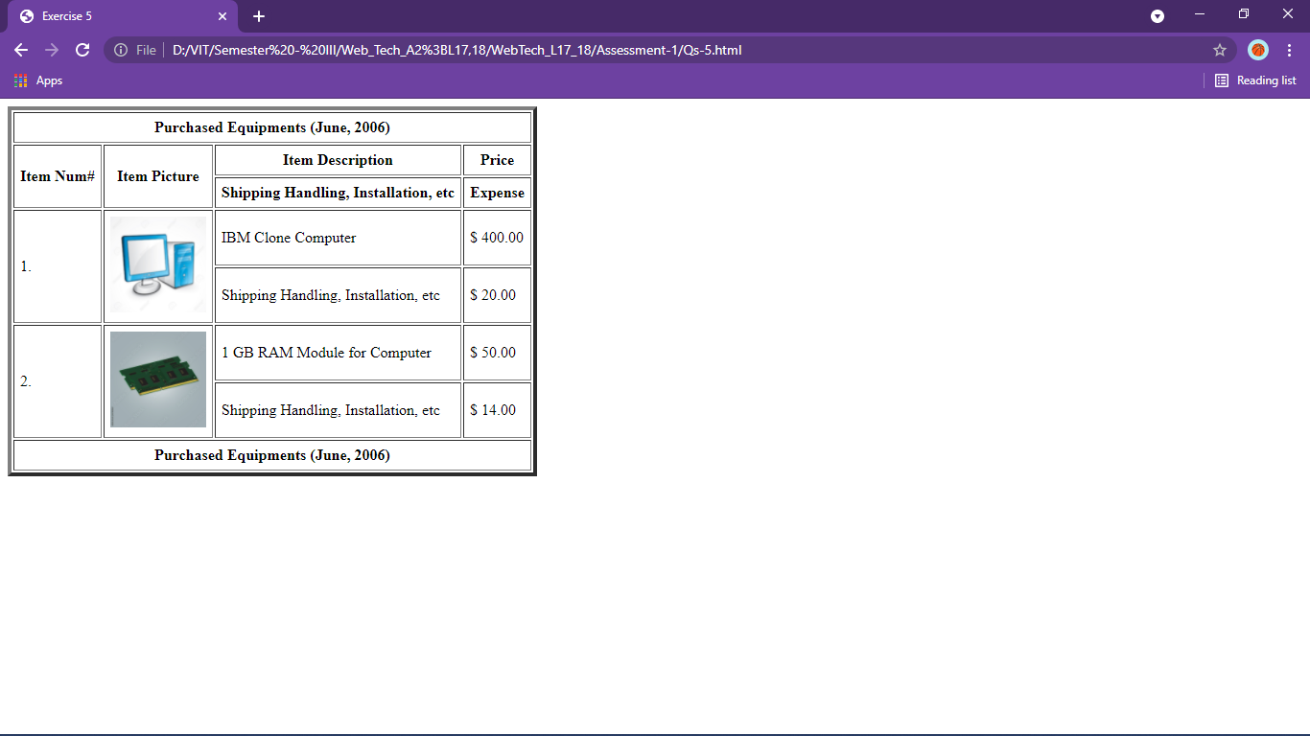

Qs6

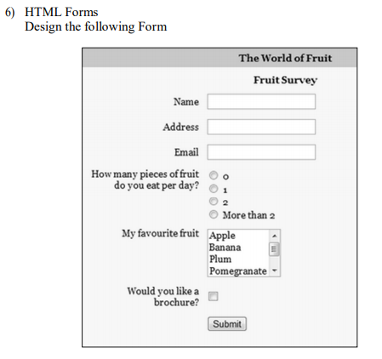

<!DOCTYPE html>

<html>

<head>

    <title>Exercise 6</title>

</head>

<body>

    <table bgcolor="#C4C4C4" border="0" cellpadding="5">

        <thead>

            <tr>

                <th colspan="2" bgcolor="grey" align="right">

                    <h2>The World of Fruit</h2>

                </th>

            </tr>

            <tr>

                <th colspan="2" align="right">

                    <h3>Fruit Survey</h3>

                </th>

            </tr>

        </thead>

        <tr>

            <td style="font-weight:bold">Name</td>

            <td>

                <input type="text" name="name" size="20" />

            </td>

        </tr>

        <tr>

            <td style="font-weight:bold">Address</td>

            <td>

                <input type="text" name="address" size="20" />

            </td>

        </tr>

        <tr>

            <td style="font-weight:bold">Email</td>

            <td>

                <input type="text" name="email" size="20" />

            </td>

        </tr>

        <tr>

            <td align="right">How many pieces of fruit<br />do you eat per day?</td>

            <td>

                <input type="radio" name="0" value="0" /><br />

                <input type="radio" name="1" value="1" /><br />

                <input type="radio" name="2" value="2" /><br />

                <input type="radio" name="More2" value="More than 2" />

            </td>

        </tr>

        <tr>

            <td align="right">Favourite fruit</td>

            <td>

                <select size="4">

                    <option value="Apple">Apple</option>

                    <option value="Banana">Banana</option>

                    <option value="Plum">Plum</option>

                    <option value="Pomegranate">Pomegranate</option>

                    <option value="Mango">Mango</option>

                </select>

            </td>

        </tr>

        <tr>

            <td align="right">Would you like a<br />brochure?</td>

            <td><input type="checkbox" value="like brochure" name="likebrochure" /></td>

        </tr>

        <tr>

            <td colspan="2" align="center">

                <input type="submit" value="Submit" name="submit" />

            </td>

        </tr>

    </table>

</body>

</html>

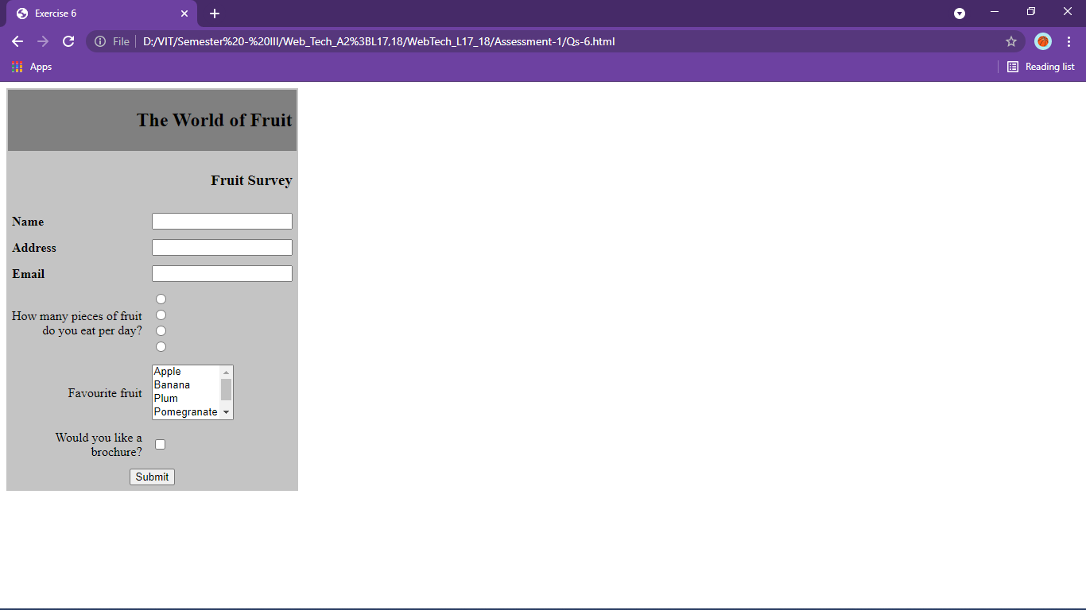

Qs7

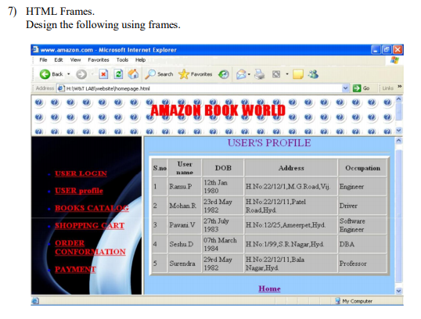

<!DOCTYPE html>

<html>

<head>

    <title>Exercise 7</title>

</head>

<frameset rows="20%,*">

    <frame name="top" src="Qs-7top.html">

    <frameset cols="25%,*">

        <frame src="Qs-7left.html" name="left">

        <frame src="Qs-7login.html" name="right">

    </frameset>

</frameset>

</html>

<!DOCTYPE html>

<html>

<head>

    <title>FrameTop</title>

</head>

<body>

    <h2 align="center">Amazon Book World</h2>

</body>

</html>

<!DOCTYPE html>

<html lang="en">

<head>

    <meta charset="UTF-8">

    <meta http-equiv="X-UA-Compatible" content="IE=edge">

    <meta name="viewport" content="width=device-width, initial-scale=1.0">

    <title>Frameleft</title>

</head>

<body>

    <ul>

        <!-- target = right to make it display in right frame -->

        <li><a href="Qs-7login.html" target="right">USER LOGIN</a></li>

        <li><a href="profile.html" target="right">USER PROFILE</a></li>

        <li><a href="Catalogue.html" target="right">BOOKS CATALOG</a></li>

        <li><a href="Payment.html" target="right">SHOPPING CART</a></li>

        <li><a href="" target="right">ORDER CONFIRMATION</a></li>

        <li><a href="" target="right">PAYMENT</a></li>

    </ul>

</body>

</html>

<!DOCTYPE html>

<html lang="en">

<head>

    <meta charset="UTF-8">

    <meta http-equiv="X-UA-Compatible" content="IE=edge">

    <meta name="viewport" content="width=device-width, initial-scale=1.0">

    <title>Login</title>

</head>

<body>

    <h1>Login</h1>

    <form>

        <label>Username: </label>

        <input type="text" name="username" placeholder="Enter username">

        <br /><br /><br />

        <label>Password: </label>

        <input type="text" name="username" placeholder="Enter username">

    </form>

</body>

</html>

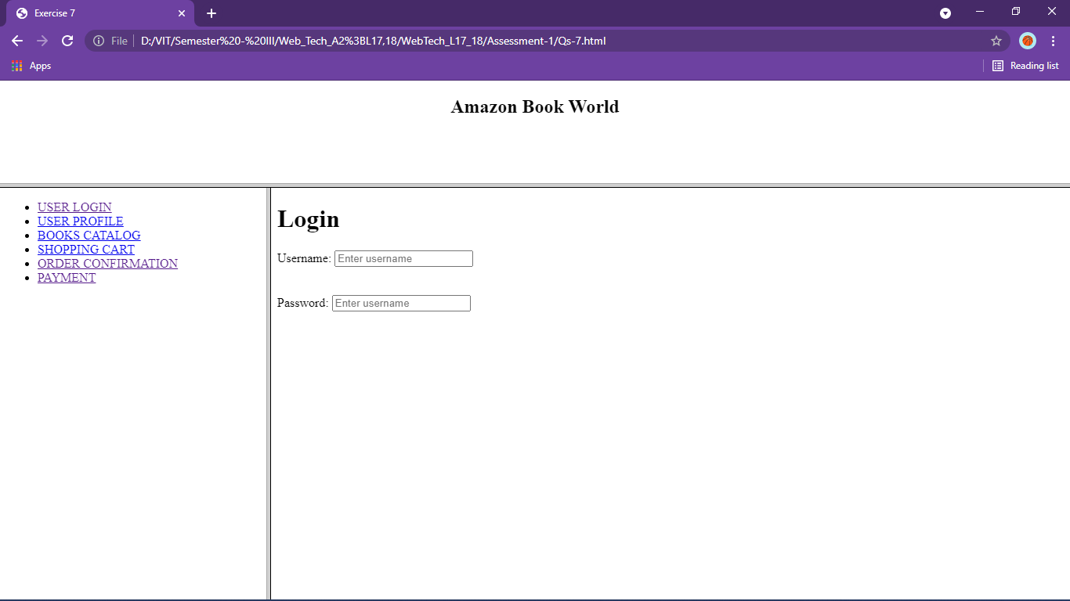

Qs8

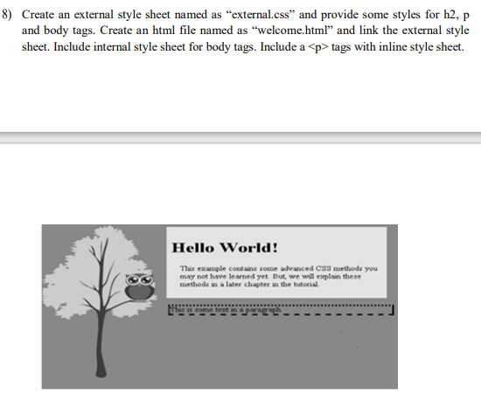

<!DOCTYPE html>

<html>

<head>

    <title>Exercise 8</title>

</head>

<link rel="stylesheet" href="external.css">

<style>

    body {

        background-color: grey;

    }

</style>

<body>

    <img src="tree.png" height="200" align="left" />

    <div>

        <h2 style="color:green;">Hello World!</h2>

        <p style="color:black;">This example contains some advanced

            CSS methods you may not have learned yet But, we will explain

            there methods in a later chapter in the tutorial</p>

    </div>

    <p style="color:purple; border-width:1px;

border-style:dotted solid dashed solid;

border-color:black;margin-left:160px;">This is come text in a paragraph</p>

</body>

</html>

body{

text-align:right;

color:#45ffab;

background-color:#73cba3;

}

div{

background-color:orange;

margin-left:160px;

}

h2{

text-align:left;

padding-left: 20px;

}

p{

text-align:justify;

padding-left:40px;

margin-left:50px;

}

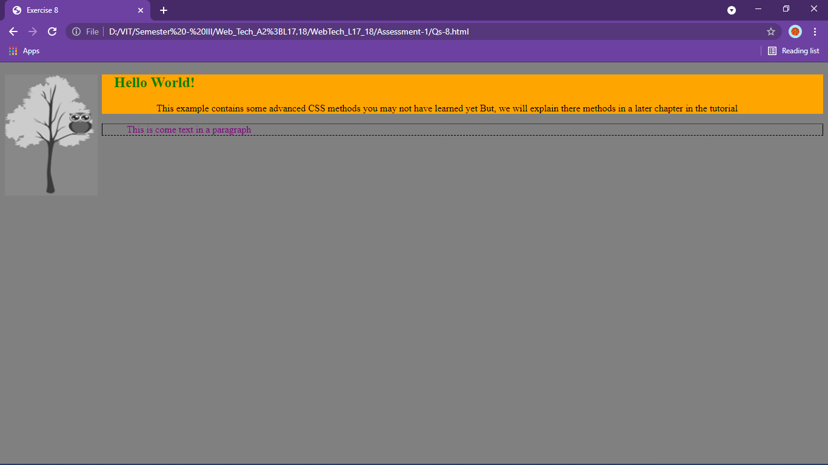

Qs9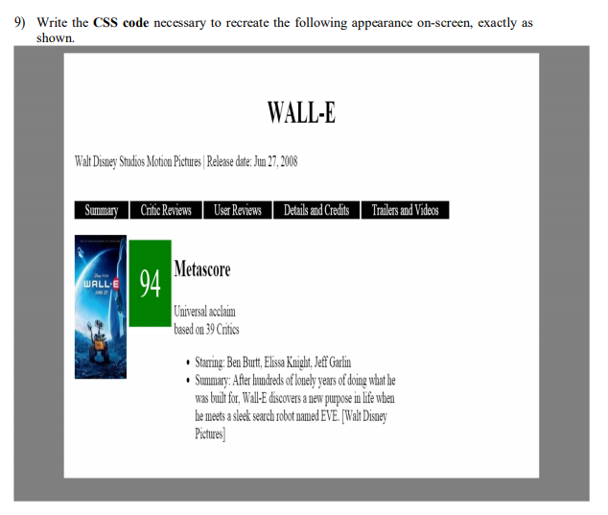

<!DOCTYPE html>

<html>

<head>

    <title>Exercise 9</title>

    <link rel="stylesheet" href="Qs-9styles.css" type="text/css">

</head>

<body>

    <div id="parent">

        <h1>Wall-E</h1>

        <p>Walt Disney Studios Motion Pictures | Release date: Jun 27,2008</p>

        <ul id="menulist">

            <li>Summary</li>

            <li>Critic Reviews</li>

            <li>User Reviews</li>

            <li>Details and Credits</li>

            <li>Trailers and Videos</li>

        </ul>

        <div id="scoreinfo">

            <img src="walle_poster.jpg" width=200px" />

            <div id="score">

                <p>94</p>

            </div>

            <h2 id="infohead">Metascore</h2>

            <p>Universal acclaim<br>based on 39 critics

            <br>

            <ul>

                <li>Starring: Ben Burtt, Elissa Knight, Jeff Garlin</li>

                <li>Sumary: WALL-E, short for Waste Allocation Load Lifter Earth-class, is the last robot left on Earth.

                    He spends his days tidying up the planet, one piece of garbage at a time. But during 700 years,

                    WALL-E has developed a personality, and he's more than a little lonely. Then he spots EVE (Elissa

                    Knight), a sleek and shapely probe sent back to Earth on a scanning mission. Smitten WALL-E embarks

                    on his greatest adventure yet when he follows EVE across the galaxy.</li>

            </ul>

            </p>

        </div>

    </div>

</body>

</html>

body{

    background: grey;

}

#parent{

    background:white;

    width: 80%;

    margin:auto;

    padding:20px;

}

#menulist{

    color:white;

}

#menulist>li{

    background-color:black;

    display:inline;

    padding:auto 20px;

    margin:3px;

}

img{

    display:inline;

}

#scoreinfo{

    /* display:inline; */

    display:flex;

}

#score{

    background-color:green;

    width:fit-content;

    margin:5px;

    padding:20px;

    color:white;

    font-size: 30px;

}

#scoreinfo > p{

    width:50%;

}

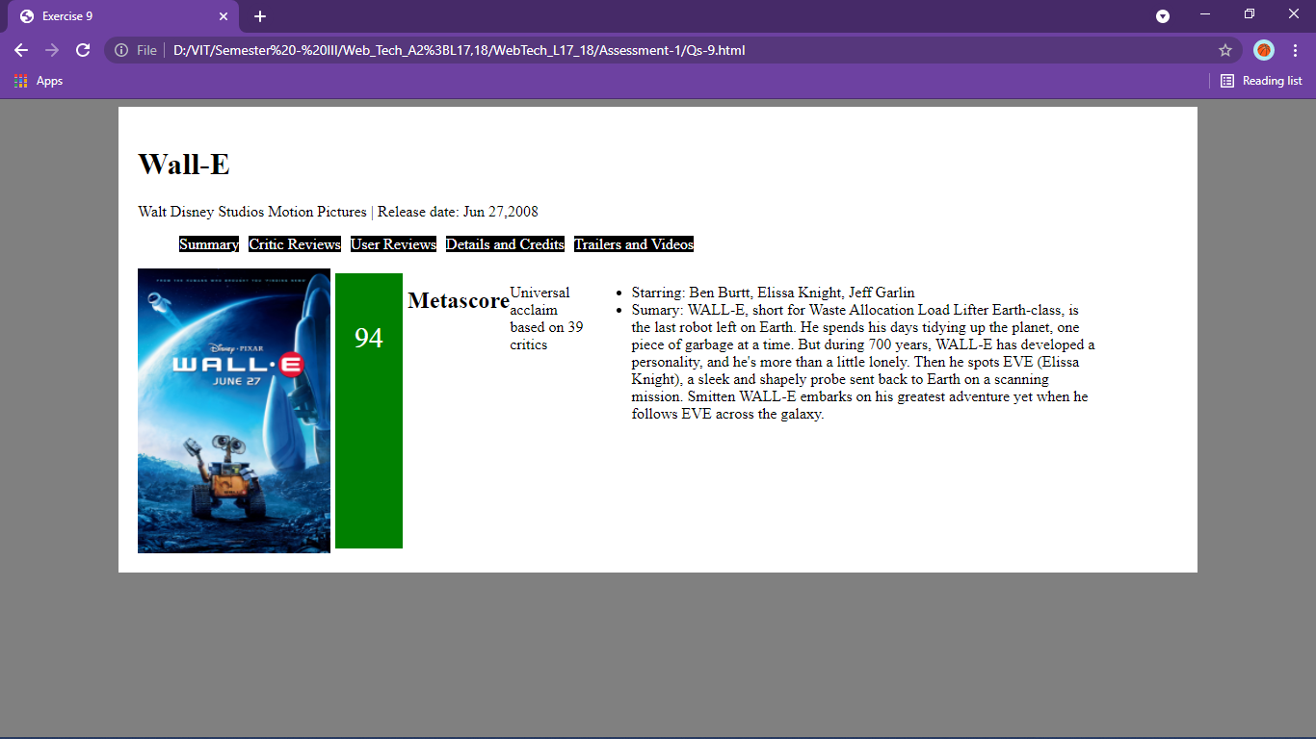

Qs10

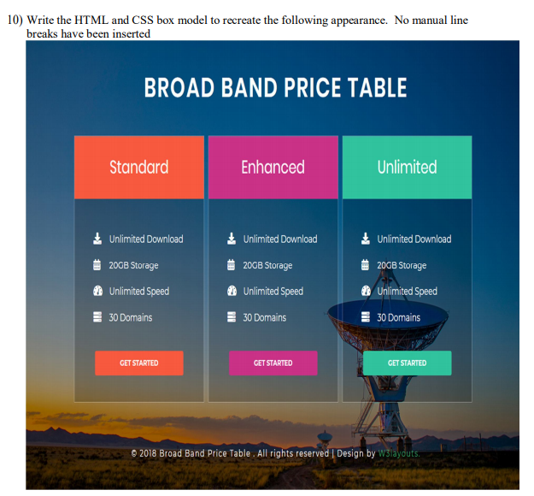

<!DOCTYPE html>

<html>

<head>

    <title>Exercise 10</title>

    <link rel="stylesheet" href="Qs-10styles.css" type="text/css">

</head>

<body>

    <h1 align="center">Broad Band Price Table</h1>

    <div id="parent">

        <div id=child>

            <h3 class=one align="center">Standard</h3>

            <ul>

                <li>Unlimited Download</li>

                <li>20GB Storage</li>

                <li>Unlimited Speed</li>

                <li>30 Domains</li>

            </ul>

            <p><input type="button" name="start" value="GET STARTED" /></p>

        </div>

        <div id=child>

            <h3 class=two align="center">Enhanced</h3>

            <ul>

                <li>Unlimited Download</li>

                <li>20GB Storage</li>

                <li>Unlimited Speed</li>

                <li>30 Domains</li>

            </ul>

            <p><input id=twobtn type="button" name="start" value="GET STARTED" /></p>

        </div>

        <div id=child>

            <h3 class=three align="center">Unlimited</h3>

            <ul>

                <li>Unlimited Download</li>

                <li>20GB Storage</li>

                <li>Unlimited Speed</li>

                <li>30 Domains</li>

            </ul>

            <p><input id=threebtn type="button" name="start" value="GET STARTED" /></p>

        </div>

    </div>

</body>

</html>

body{

    background-image:url("pexels-pixabay-531880.jpg");

    background-size: cover;

}

#parent{

    display: grid;

    grid-template-columns: 1fr 1fr 1fr;

    width:90%;

    margin:auto;

}

#child{

    background-color: rgba(0,0,0,0.5);

    margin:auto 10px;

    padding:0;

    padding-bottom: 20px;

    width:80%;

}

#child > ul{

    width:fit-content;

    margin:auto;

}

li{

    margin:40px;

    color:white;

}

#child > p{

    width:fit-content;

    margin:10px auto;

}

.one{

    background-color:orange;

    margin-top:0px;

    padding:30px 20px;

}

.two{

    background-color:magenta;

    margin-top:0px;

    padding:30px 20px;

}

.three{

    background-color:green;

    margin-top:0px;

    padding:30px 20px;

}

input{

    padding:15px 20px;

    background-color: orange;

    border:none;

}

